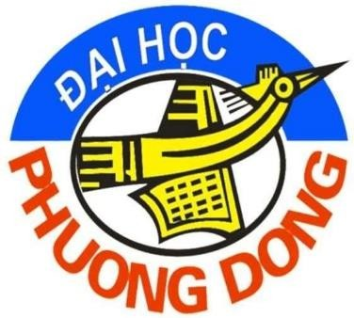

MINISTRY OF EDUCATION AND TRAINING PHUONG DONG UNIVERSITY

FINAL ASSIGNMENT

AN ASSESSMENT ON THE ARTICLE ENTILED

“Academic Writing Difficulties Encountered by University EFL Learners”.

Student: Nguyễn Khương Trung Field : English Language
Class : 519701B2
Supervisor: Bùi Thị Phương M.A

Hanoi, 2022

ACKNOWLEDGEMENT

First of all, I would like to express my gratitude and gratefulness to my supervisor Ms. Bùi Thị Phương for guiding me to complete the essay, helping me answer questions during the writing process and giving suggestions as well as feedback so that I can complete the essay in the most effective results.
I also acknowledge my thankfulness to all of the teachers at Phuong Dong University who have given conditions for me to complete my assignment.
At last, my deeply thanks come to my classmates and friends who have contributed their valuable suggestions and comments to enrich the quality of my assignment.

